6-12 Professional Development Guidelines
2021-2022
Benson School District
District 777
Benson, MN 56215


2021-2022 Meeting Dates:
2nd Wednesday of each month or more often when necessary

*Requests must be submitted prior to meeting dates in order to receive approval in a timely manner for registration and payment purposes. Please be aware of workshop dates when submitting requests.

6-12 Professional Development Committee Members 2020-2021
*The District has a PK-5 Committee for and a 6-12 Committee
Tom Foley tfoley@benson.k12.mn.us Math
Michelle Goossen mgoossen@benson.k12.mn.us English
Renee Helgenset rhelgenset@benson.k12.mn.us Language
Mike Knutson mknutson@benson.k12.mn.us 6-12 Principal
Steve Ricard sricard@benson.k12.mn.us Social Studies
Jeff Guest jguest@benson.k12.mn.us Special Education

Role of Committee
- Meet monthly during the school year for organizational purposes with special meetings as needed.
- Allocate staff development funds as directed by Minnesota statutes
- Formulate annual 6-12 Professional Development Committee goals.
- Arrange professional development activities to meet identified needs.
- Notify staff and area substitutes of staff development activities.
- Provide for follow-through activities/evaluation after in-service and individual staff activities.
- Correlate professional growth activities.
- Update Professional Development plan each year.
- Receive Professional Development expense reports from the district.
- Act on fully completed requests.

How to Submit a Professional Development Request

Professional development requests* can be submitted using our online request form. Additional paperwork may be required. If a substitute is necessary, be sure to enter your absence into the AESOP system.
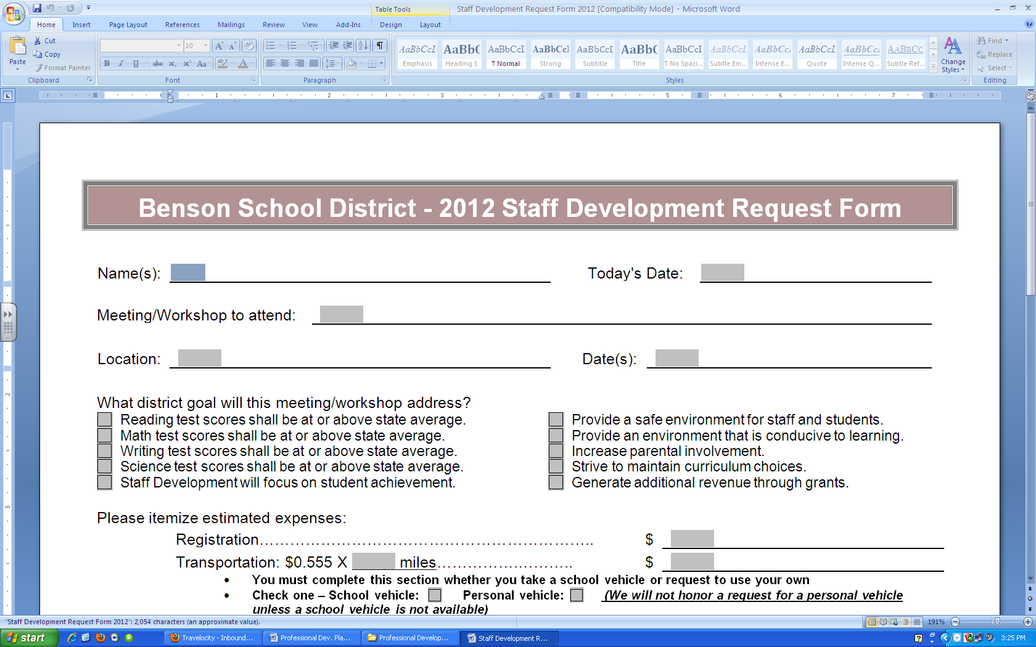
STEP 1: Fill out and submit the request
GO TO: District Office > Staff Resources > Staff Development Form
STEP 2: If necessary fill out the following forms
- Workshop registration form + registration requisition form
- Lodging requisition form
- Travel requisition form (NOT to be used for district vehicles)
STEP 3: Turn all paperwork over to Mike Knutson prior to the staff development meeting. Requests cannot be approved if the accompanying paperwork is missing or incomplete.

REQUISITION FORM: Each vendor needs a separate and complete requisition form. It is possible that a professional development request could require several, separate requisition forms. Requisitions should be completed through ESS.

*Requests that are not traditional workshops can still be submitted using the form. Faculty members should fill out the fields to the best of their ability using complementary language in the text boxes.

*Note: The Staff Development Committee acts upon requests. If your request is approved you will need to submit the requisitions and/or necessary paperwork to the business office.

Professional Development Funding

Funds allocated by the State to the Benson School District for the purpose of Professional Development may be used for:
- Inservice training related to the Professional Development goals
- Challenging instructional experiences
- Professional development programs for the purposes of improving student achievement
- Curriculum writing for a course utilizing on-line, Codec, and/or ITV delivery method. Up to 90 hours for a year-long course and up to 45 hours for a semester course.
- Generally, only one person per department/grade level will be approved to attend conferences. Those attending conferences are responsible to share information learned at a conference with colleagues.
- A staff member who is approved by administration to take courses, but can no longer advance in lanes from the credits completed, is eligible to apply for $100 per credit completed.

Acceptable Uses for Professional Development Money

Individual professional development money allocated for staff members may be used in any of the following ways, with the approval of the building principal or site committees:

- develop curriculum (10 hrs. maximum per fiscal year, 15 hours per semester)
- purchase professional development materials
- site approved workshops or conferences
- MRVED activities
- mentor a novice teacher
- join a study group
- action research project
- take training on technology
- shadow another teacher
- visit another school/program
- lead study group
- professional journals (excluding membership to councils)

- Stipend: Summer/Weekend conferences and/or workshops ($100 full day/$400 year max.)
- Conferences: All requests for professional conferences will be considered on a first come, first serve basis. Hotel, registration, transportation, and meals will be covered for conference attendance. Staff development does not pay for out of state travel.

Professional Development

What is meant by “high-quality professional development”?
“High-quality professional development” means professional development that meets the criteria contained in the definition of professional development in Title IX, Section 9101 (34) of ESEA. Professional development includes, but is not limited to, activities that:
- Improve and increase teacher’s knowledge of the academic subjects teachers teach, and enable teachers to become highly qualified.
- Are an integral part of broad school wide and district wide educational improvement plans.
- Give teachers, principals, and administrators the knowledge and skills to provide students with the opportunity to meet challenging State academic content standards and student academic achievement standards.
- Improve classroom management skills.
- Are high quality, sustained, intensive, and classroom-focused in order to have a positive and lasting impact on classroom instruction and the teacher’s performance in the classroom and are not 1-day or short-term workshops or conferences.
- Support the recruiting, hiring, and training of highly qualified teachers, including teachers who became highly qualified through State and local alternative routes to certification.
- Advance teacher understanding of effective instructional strategies that are based on scientifically based research and strategies for improving student academic achievement or substantially increasing the knowledge and teaching skills of teachers.
- Are aligned with and directly related to State academic content standards, student academic achievement standards, and assessments.
- Are developed with extensive participation of teachers, principals, parents, and administrators of schools to be served under this Act.
- Are designed to give teachers of limited English proficient children, and other teachers and instructional staff, the knowledge and skills to provide instruction and appropriate language and academic support services to those children, including the appropriate use of curricula and assessments.
- To the extent appropriate, provide training for teachers and principals in the use of technology so that technology and technology applications are effectively used in the classroom to improve teaching and learning in the curricula and core academic subjects in which the teachers teach.
- As a whole, are regularly evaluated for their impact on increased teacher effectiveness and improved student academic achievement, with the findings of the evaluations used to improve the quality of professional development.
- Provide instruction in methods of teaching children with special needs.
- Include instruction in the use of data and assessments to inform and instruct classroom practice.
- Include instruction in ways that teachers, principals, pupil services personnel, and school administrators may work more effectively with parents.

6-12 Professional Development Committee Goals

Reading Goal: | -Meet/Exceed State Average | -PLC Meetings  -analyze data
Math Goal: | -Meet/Exceed State Average | - PLC Meetings  -analyze data
Science Goal: | -Meet/Exceed State Average | - PLC Meetings  -analyze data
Technology Goal: | -Increase use of technology with staff and students  -1 to 1 Chromebook initiative | -Use of 1 to 1 technology  -Use of Google Classroom

